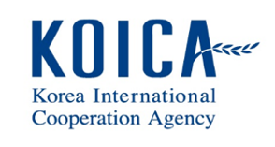
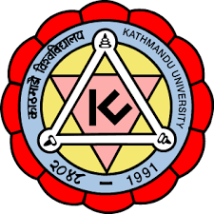

Kathmandu University-Integrated Rural Development Project/
Nepal Technology Innovation Center
Call for Application

Call Published date: 21 November, 2021
Deadline: 21 December, 2021
Briefing Session: 10 December, 2021
- KU-NTIC/IRDP, a KOICA-funded project jointly managed by Kathmandu University (KU), Nepal and Jeonbuk National University (JBNU), Korea opens a call for all the Nepalese citizens with an aim to:
  - Support technologies development to solve economic and social problems of rural areas in Nepal.
  - Develop a business model or commercialization for propagation of innovative technologies.
  - Test if an operation plan of technology development support is valid and feasible.
  - Generate information that is crucial for future technological innovations for rural development.

- The main objective of the KU-IRDP/NTIC program is to contribute for integrated rural development of Nepal by strengthening research and development capacity of Kathmandu University. The call is opened to promote technology innovation for improving quality of life and income status of people in rural communities of Nepal mainly in the field of:
  - Agriculture & Rural Development,
  - Alternative and Renewable Energy and
  - Health Related Livelihood
  - Other Sectors Contributing to Integrated Rural Development

- Interested applicant may obtain further information during office hour. A complete set of documents for application and guidelines mentioned below can be downloaded from KU-NTIC/IRDP website (http://ntic.ku.edu.np).
  - Guidelines for R&BD Budgeting and Accounting
  - Management and Operational Guidelines
  - Project Proposal Form
  - Participating Researcher’s Profile
  - Project Participation Agreement Form

- Project support fund and details are presented below:
Category | Details
Total Support Fund | NRs. 3,00,00,000
Support Period | 2022.01 ∼ 2023. 04 (Within 16 months)
Support Fund | Up to NRs. 5,000,000 per project

- Proposal document having signed on each page by authorized personnel must be submitted not later than 21 December, 2021 until 12:00 PM, local time. The document received later than the above-mentioned time and date will not be considered. Electronic submission must be done through email at ntic@ku.edu.np on or before 12 PM on 21 December, 2021. Proposal received after this deadline will be rejected.

- If the last date of submission falls on a Government/Kathmandu University holiday, then the
next working day shall be considered as a deadline.

- Costs incurred for preparation of applications and site visits are to be borne by the applicant.

- KU-IRDP/NTIC reserves the right to accept or reject any or all applications, cancel the process and reject all proposal applications without assigning any reason whatsoever. The applicant shall have no right to claim any cost associated with the preparation of proposal document under such circumstances.

For Further Information
Contact No.: +977-9802310110, 9802310108
Email Address: irdp@ku.edu.np
ntic@ku.edu.np

